- Textures
Crosshairs
Cross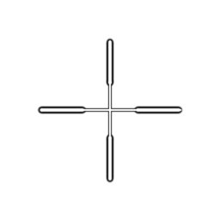
X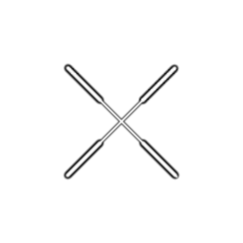
Dot
Triangle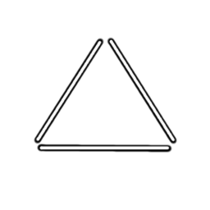
Trefoil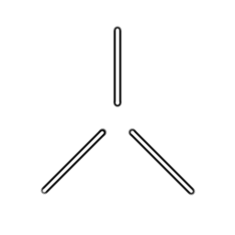
Box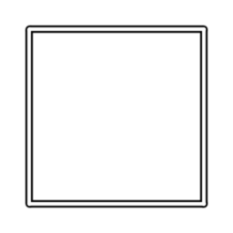
Circle
Rangefinder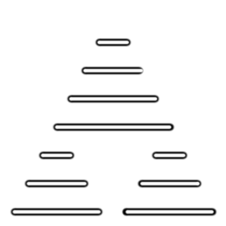
Box Cross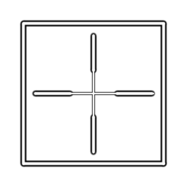
Box Dot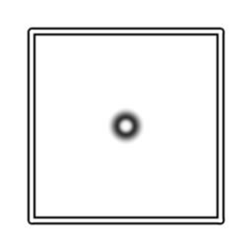
Box X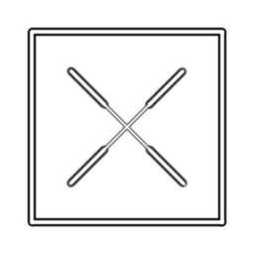
Circle Cross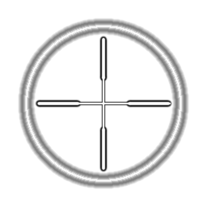
Circle Dot
Circle X

Metal
dimpled, rough and scratchy, Rusty, Holey, verdigris, Brushed, galvanized, Corrugated, Grate, Fence, Louvred Vent, Duct
Rock
smooth, conglomerate, Sandy, Gravelly, Pitted, jagged, marble, slate, limestone, Granite, Sandstone
Icons
Ammo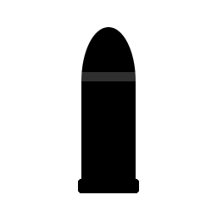
Up Arrow
Carryable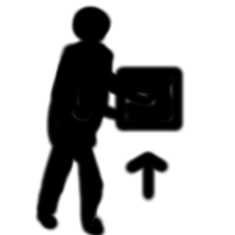
Controllable
Controller 
Door 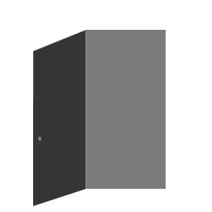
Health
Key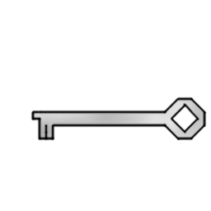
Light 
Sky 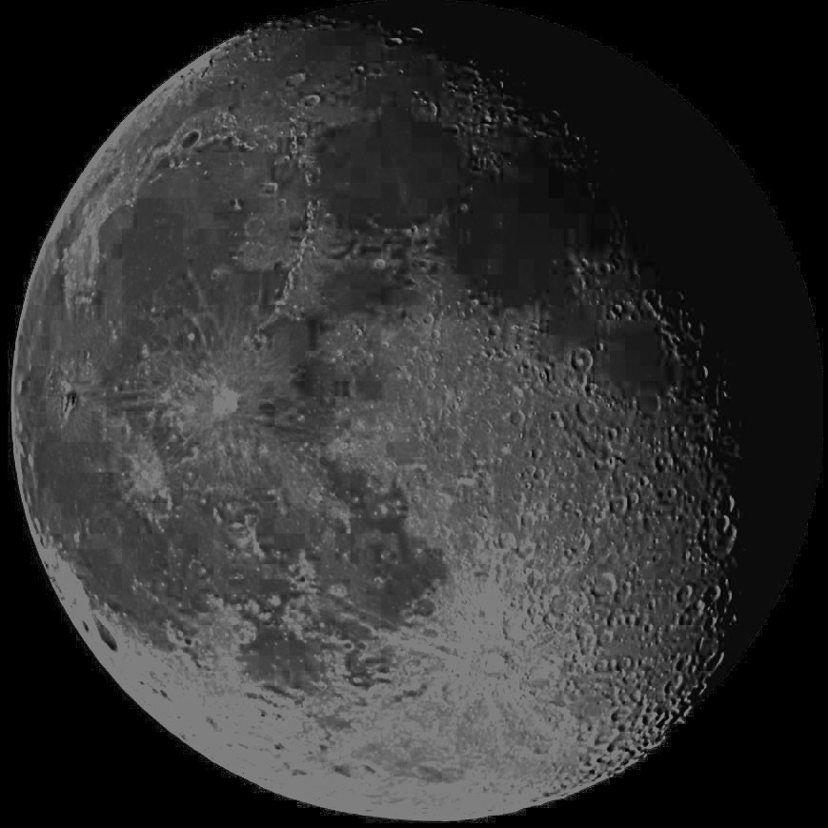
Pawn 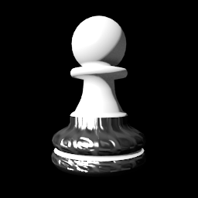
Ruler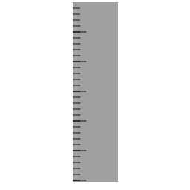
Shield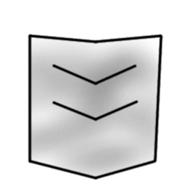
Stairs 
Strength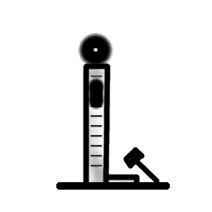
Switch
Weapon 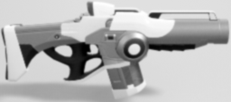

Cloth
Fine Weave, Coarse Weave, Carpet
Decals
bullet holes, footprints, Stain, signs, puddles, Dirt, Scratches,{\Scrv_annot \color={\R=1.000000\G=0.000000\B=0.000000} \text=TODO\end_Scrv_annot}
Wall
Plaster, wood, wood with grain, particleboard, Wood with knots,{\Scrv_annot \color={\R=1.000000\G=0.000000\B=0.000000} \text=TODO\end_Scrv_annot} brick, concrete, concrete block, Stone
Floor
tiles of various types and shapes, cobblestone, Concrete, Concrete grime, Concrete Panels, Concrete Tiles, Concrete grooved, Concrete Pitted, Concrete Plank-like {\Scrv_annot \color={\R=1.000000\G=0.000000\B=0.000000} \text=TODO\end_Scrv_annot}
Ground
Dirt, Mud, Gravel, Grass, Snow, Patchy Grass, Ice, Dirty Ice, Rough Ice, Dirty Snow, Patchy Snow, Exposed Rock, muddy rocks, Moss, Dirt and Pebbles,{\Scrv_annot \color={\R=1.000000\G=0.000000\B=0.000000} \text=TODO\end_Scrv_annot}
Ground with Foliage
Utility
noise, clouds, gradients
Other
Painted metal, colored glass, patterned cloth, etc{\Scrv_annot \color={\R=1.000000\G=0.000000\B=0.000000} \text=TODO\end_Scrv_annot}
Leather, Rubber, Plastic, Ceramic, etc. to match PhysMats
Hazard patterns
Grids and tile patterns, hex and square, etc. Holey patterns, Vent louvre patterns, etc.
Diamond Plate, Duct, Planks, Parquet

